**CSC258 – Lab1 Pufan Zhao & ZiYu Zhang**

**Part 1: 1002744021 & 1001426076**

**Function**: *f = xs’ + ys*

**Truth Table** :

|  |  |  |  |
| --- | --- | --- | --- |
| S | X | Y | Z |
| 0 | 0 | 0 | 0 |
| 0 | 0 | 1 | 0 |
| 0 | 1 | 0 | 1 |
| 0 | 1 | 1 | 1 |
| 1 | 0 | 0 | 0 |
| 1 | 0 | 1 | 1 |
| 1 | 1 | 0 | 0 |
| 1 | 1 | 1 | 1 |

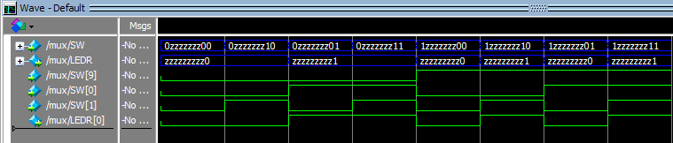Conclusion: The result of the generated waveform matches the truth table.